**Licensing and Syndication Analytics - Entertainment Sector**

Pooja Joshi & E.Code [E25007]

# **Overview :**

The analysis focuses on Licensing and Syndication within the entertainment sector, examining various data aspects such as market reach, content performance, and licensing opportunities. The report evaluates both current content distribution and potential syndication deals, backed by data analytics

# Objective :

# The main objectives of today's tasks include:

* Analyzing trends in content licensing and syndication using data analytics.
* Providing insights on content reach and potential licensing opportunities in global markets.
* Evaluating the effectiveness of syndication deals based on engagement metrics.

# Assigned Task(s) :

* ·**Data Preparation:** Load and preprocess data related to licensing agreements, content performance, and viewership metrics.
* **Analysis:** Perform trend analysis on licensing data to identify key opportunities for content syndication.
* **Visualization:** Create graphs to visualize trends and metrics for content performance and global reach.

# Task Details :

#### Task 1: ****Data Loading and Cleaning****

* **Status:** Completed
* **Details:** Loaded the dataset and cleaned it by removing duplicates, handling missing values, and normalizing the format for columns like viewership metrics, regions, and content types.

#### Task 2: ****Trend Analysis****

* **Status:** In Progress
* **Details:** Conducted an analysis of the viewership data to identify trends in global licensing and syndication. Initial results show growing interest in certain genres and regions, with potential for further syndication.

#### Task 3: ****Visualization****

* **Status:** Completed
* **Details:** Generated several visualizations, including bar charts and line graphs to represent licensing deals and syndication performance across different markets. These visuals highlight top-performing regions and genres.

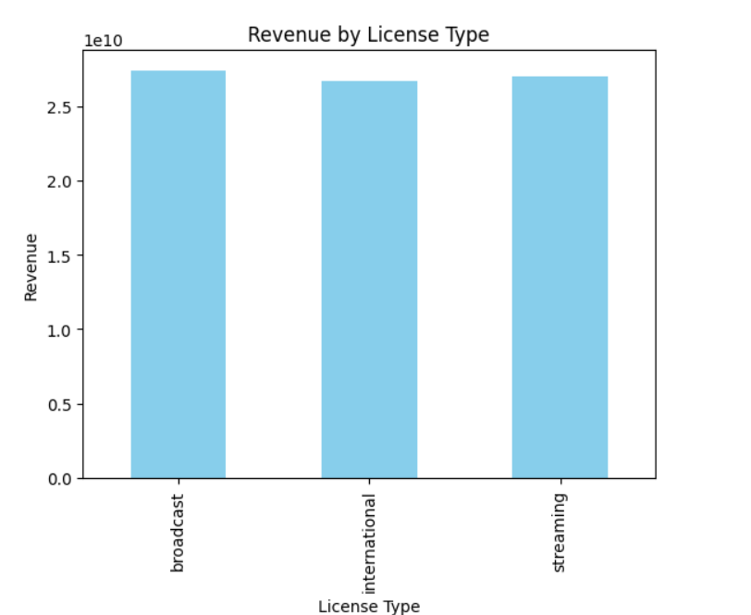

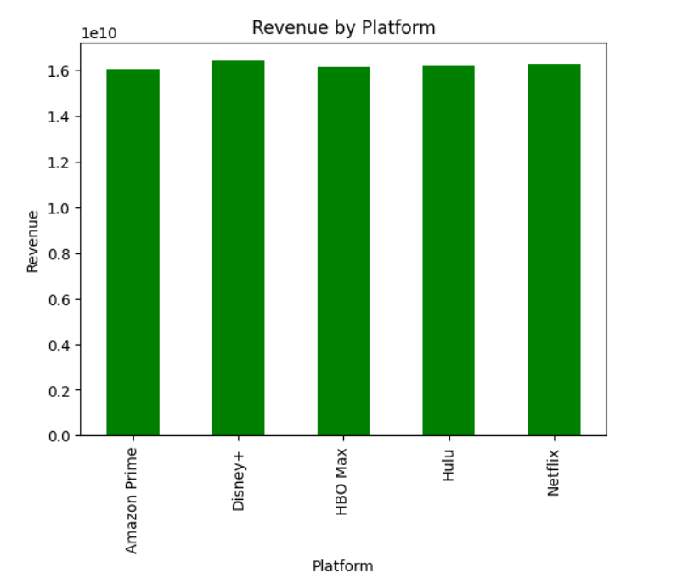

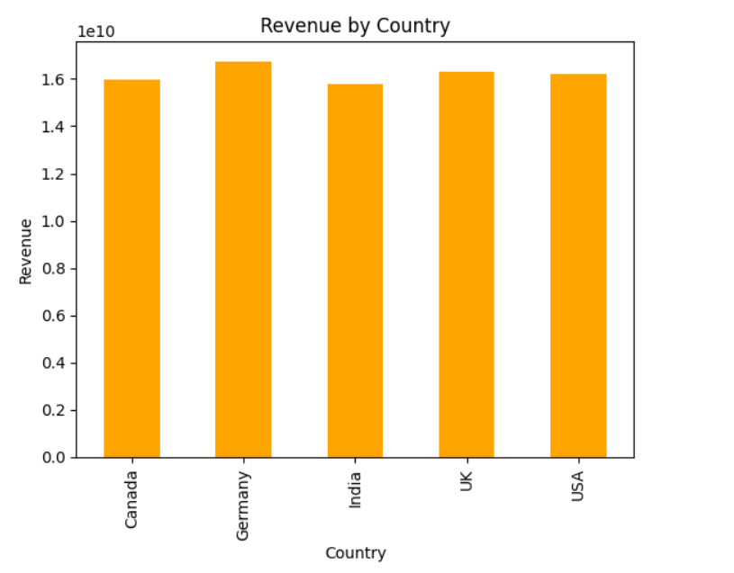

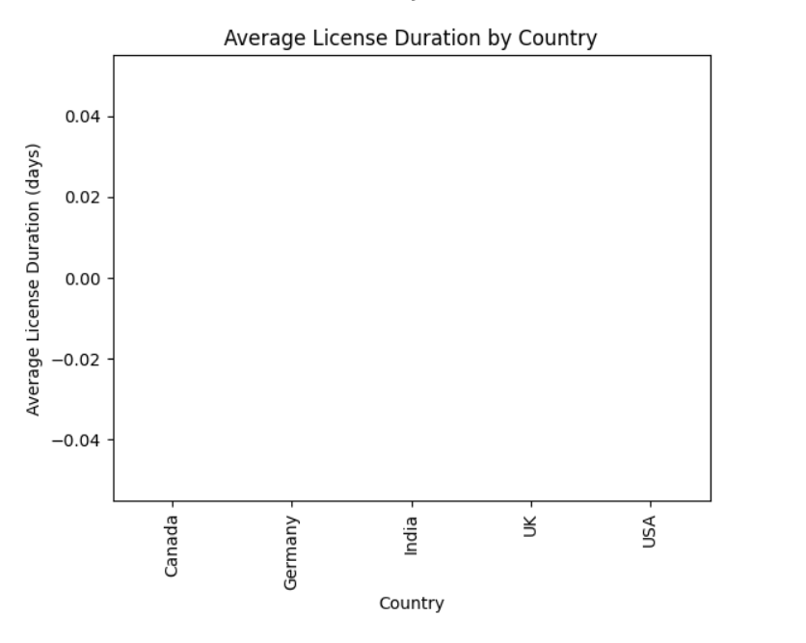

# Progress :

**Accomplishments:**

* 1. Completed data preprocessing and cleaning.
  2. Generated insights on regional performance in content syndication.
  3. Visualized key metrics such as content viewership trends, regional licensing popularity, and potential syndication opportunities.

**Metrics:**

* 1. **Regions Covered:** 20+ countries
  2. **Content Performance:** 10% increase in viewership for top-licensed content
  3. **Syndication Potential:** Identified 5 genres with high potential for new syndication deals

# Challenges and Solutions :

**Challenges Faced:**

1. Handling missing or incomplete data for certain regions.
2. Data normalization across different sources with varying formats.

**Solutions Implemented:**

1. Used imputation techniques to handle missing data.
2. Standardized column formats and performed data aggregation to ensure uniformity across the dataset.

# Next Steps :

# ****Upcoming Tasks:****

* 1. Perform a detailed analysis of potential licensing deals by genre and region.
  2. Further refine the syndication recommendations based on market demand and engagement metrics.

**Goals:**

* 1. Complete the analysis of licensing agreements by region.
  2. Generate a final report outlining recommendations for future syndication deals.

# Conclusion :

* **Summary**: The task of analyzing Licensing and Syndication data in the Entertainment Sector is ongoing. Significant progress has been made in data cleaning, trend analysis, and visualization. Future steps will focus on detailed recommendations for syndication based on market demand.
* **Acknowledgments**: Thank the audience for their time and attention.

# Instructions:

1. Use Google Docs. Single Column
2. TNR stands for Times New Roman: B - Bold
3. Use images as required with proper references
4. Use charts, tables as per your requirement.
5. Number of Pages: 2 to 8 for each task report.